**ABSTRACT**

The purpose of this study was to develop a blood bank management information system to assist in the management of blood donor records and ease/or control the distribution of blood basing on the hospital and receivers demands. Without quick and timely access to donor records, creating market strategies for blood donation, lobbying and sensitization of blood donors becomes very difficult .The blood management information system offers functionalities to quick access to donor records. It enables monitoring of the results and performance of the blood donation activity such that relevant and measurable objectives of the organization can be checked .It provides to management timely, confidential and secure medical reports that facilitates planning and decision making and hence improved medical service delivery.

The proposed of Blood Bank Website helps the people who are in need of a blood by giving them all details of blood group availability or regarding the donors with the same blood group. They don’t need to go anywhere to search the blood when they need. They just need to use this website then all the result will appear in just a second .Our life is so busy so we don’t have time to spend going here and there, we can use technical way to search the blood by using the Blood Bank software we can find thousands of people who are donating the blood and also get the detail the of that person’s phone number, Email address and what is the Blood group of that person .So this is the most useful website ever.

**ACKNOWLEDGEMENT**

Over the duration of our bachelor degree, we have developed our ambition to involve ourselves in the development of our project in the changing world of computer networks and it our pleasant day to thank all those who have been inspiring and support towards the development of this project.

Special thanks to our beloved principal Dr.Geetha Samak, for continuous encouragement to this project.

We extend our appreciation to Mrs. Nethravathi H H.O.D Department of Computer Science, DVS College of Arts, Science and Commerce, Shivamogga for her knowledge and moral support.

Inspiration and guidance are invaluable in all of life, especially in academic studies. We thank and express our deep sense of gratitude to our project Guide Mr. Basavaraj C M, Assistant Professor Department of Computer Science, DVS College of Arts, Science and Commerce, Shivamogga for his encouragement and supervision till the end of our project.

We extend our hearties thanks to our parents and friends for their continuous encouragement, help and suggestions.

**ABSTRACT**

**ACKNOWLEDGEMENT**

**CONTENTS**

**CHAPTER 1: INTRODUCTION.......................................................**

* 1. Introduction to the system
  2. Objective of the project
  3. Aim of the project

**CHAPTER 2: LITERATURE SURVEY............................................**

2.1 Language Used

2.1.1 PHP

2.1.2 HTML 5

2.1.3 CSS 3

2.1.4Java Script

2.2 Web server: XAMPP

2.3 MySQL

**CHAPTER 3: SYSTEM ANALYSIS..................................................**

3.1 Existing System

3.2Proposed System

3.3 System Modules

3.4 Feasibility Study

3.4.1 Operational Feasibility

3.4.2Technical Feasibility

3.4.3Economic Feasibility

**CHAPTER 4: SYSTEM REQUIRMENT..........................................**

4.1 Hardware Requirement

4.2 Software Requirement

4.3 Functional Requirements

4.3.1 Reliability

4.3.2 Efficiency

4.3.3 Reusability

4.3.4 Integrity

**CHAPTER 5: SYSTEM DESIGN.....................................................**

5.1 System Architecture

5.2 Dataflow Diagram

5.2.1 Level 0 DFD

5.3 E-R Diagram

5.4 E-R Diagram user

5.5 E-R Diagram admin

5.6 Database Connectivity

5.7 Session

5.8 MD5 Encryption

**TESTING..............................................................**

**SNAPSHOTS........................................................**

**CONCLUSION.....................................................**

**FUTURE ENHANCMENT……………………………..**

**CHAPTER 01**

**INTRODUCTION**

* 1. **INTRODUCTION**

The software system is an online blood bank management system that helps in managing various blood bank operations effectively. The project consists of a central repository containing various blood deposits available along with associated details. These details include blood type, user basic details, and user health details. These details help in maintaining and monitoring the blood deposits. The project is an online system that allows checking weather required blood deposits of a particular group are available in the blood bank. Moreover the system also has added features such as certain blood group is posted on the website to find available donors for a blood emergency. This online system is developed on PHP platform and supported by a Sql database to store specific details.

The purpose of this study is to develop a blood bank management information system to assist in the management of blood donor records and blood availability and ease the distribution of blood to acceptor demands. Using this application user can easily get the blood donor’s information and he/she can also check the availability of their required blood group. Here user can view/download their certificate as well.

**1.2 OBJECTIVE OF THE PROJECT**

The main objective of this project is to build a website which will help the blood accepters to view/check the availability of the required blood group in a blood bank or in other case if there is no availability of the blood then acceptor can easily get the information about the blood donors. The blood donors can view his certificate which contains the details about number of times they donated. The blood bank can easily get the details about the blood stock and blood donor information.

**1.3 AIM OF THE PROJECT**

The purpose of this study is to develop a blood bank management information system to assist in the management of blood donor records and blood availability and ease the distribution of blood to acceptor demands. Using this application user can easily get the blood donor’s information and he/she can also check the availability of their required blood group. Here user can view/download their certificate as well.

The main aim of developing this website is to provide blood to the people who are in need of blood. The numbers of persons who are in need of blood are increasing in large number day by day. Using this website user can search the blood group available in the city and he can also get contact number of the donor who has the same blood group. In order to help people who are in need of blood, this Online Blood Bank website can be used effectively for getting the details of available blood groups and user can also get contact number of the blood donors having the same blood group and within the same city.

**CHAPTER 02**

**LITERATURE SURVEY**

**2.1 Language used:**

**2.1.1 PHP**

PHP is a server side scripting language that is used to develop Static websites or Dynamic websites or Web applications. PHP stands for Hypertext Pre-processor, that earlier stood for Personal Home Pages. PHP scripts can only be interpreted on a server that has PHP installed. The client computers accessing the PHP scripts require a web browser only. A PHP file contains PHP tags and ends with the extension ".php".

The term PHP is an acronym for PHP: Hypertext Preprocessor. PHP is a server-side scripting language designed specifically for web development. PHP can be easily embedded in HTML files and HTML codes can also be written in a PHP file. The thing that differentiates PHP with client-side language like HTML is, PHP codes are executed on the server whereas HTML codes are directly rendered on the browser.

PHP: Hypertext Preprocessor (or simply PHP) is a general-purpose programming language originally designed for web development. It was originally created by Rasmus Lerdorf in 1994.PHP code may be executed with a command line interface (CLI), embedded into HTML code, or used in combination with various web template systems, web content management systems, and web frameworks. PHP code is usually processed by a PHP interpreter implemented as a module in a web server or as a Common Gateway Interface (CGI) executable. The web server outputs the results of the interpreted and executed PHP code, which may be any type of data, such as generated HTML code or binary image data. PHP can be used for many programming tasks outside of the web context, such as standalone graphical applications and robotic drone control.

**2.1.2 HTML5**

Hypertext Markup Language (HTML) is the standard markup language for documents designed to be displayed in a web browser. It can be assisted by technologies such as Cascading Style Sheets (CSS) and scripting languages such as JavaScript. Web browsers receive HTML documents from a web server or from local storage and render the documents into multimedia web pages. HTML describes the structure of a web page semantically and originally included cues for the appearance of the document.

HTML elements are the building blocks of HTML pages. With HTML constructs, images and other objects such as interactive forms may be embedded into the rendered page. HTML provides a means to create structured documents by denoting structural semantics for text such as headings, paragraphs, lists, links, quotes and other items. HTML elements are delineated by tags, written using angle brackets. Tags such as <img /> and <input /> directly introduce content into the page. Other tags such as <p> surround and provide information about document text and may include other tags as sub-elements. Browsers do not display the HTML tags, but use them to interpret the content of the page.

HTML can embed programs written in a scripting language such as JavaScript, which affects the behavior and content of web pages. Inclusion of CSS defines the look and layout of content. The World Wide Web Consortium (W3C), former maintainer of the HTML and current maintainer of the CSS standards, has encouraged the use of CSS over explicit presentational HTML since 1997.

**2.1.3 CSS**

Cascading Style Sheets (CSS) is a style sheet language used for describing the presentation of a document written in a markup language like HTML.CSS is a cornerstone technology of the World Wide Web, alongside HTML and JavaScript.CSS is designed to enable the separation of presentation and content, including layout, colors, and fonts. This separation can improve content accessibility, provide more flexibility and control in the specification of presentation characteristics, enable multiple web pages to share formatting by specifying the relevant CSS in a separate .css file, and reduce complexity and repetition in the structural content.

CSS information can be provided from various sources. These sources can be the web browser, the user and the author. The information from the author can be further classified into inline, media type, importance, selector specificity, rule order, inheritance and property definition. CSS style information can be in a separate document or it can be embedded into an HTML document. Multiple style sheets can be imported. Different styles can be applied depending on the output device being used; for example, the screen version can be quite different from the printed version, so that authors can tailor the presentation appropriately for each medium. The style sheet with the highest priority controls the content display. Declarations not set in the highest priority source are passed on to a source of lower priority, such as the user agent style. The process is called cascading.

One of the goals of CSS is to allow users greater control over presentation. Someone who finds red italic headings difficult to read may apply a different style sheet. Depending on the browser and the web site, a user may choose from various style sheets provided by the designers, or may remove all added styles and view the site using the browser's default styling, or may override just the red italic heading style without altering other attributes.

**2.14 JAVA SCRIPT**

JavaScript s a high-level, interpreted scripting language that conforms to the ECMAScript specification. JavaScript has curly-bracket syntax, dynamic typing, prototype-based object-orientation, and first-class functions. Alongside HTML and CSS, JavaScript is one of the core technologies of the World Wide Web.JavaScript enables interactive web pages and is an essential part of web applications. The vast majority of websites use it, and major web browsers have a dedicated JavaScript engine to execute it.As a multi-paradigm language, JavaScript supports event-driven, functional, and imperative (including object-oriented and prototype-based) programming styles. It has APIs for working with text, arrays, dates, regular expressions, and the DOM, but the language itself does not include any I/O, such as networking, storage, or graphics facilities. It relies upon the host environment in which it is embedded to provide these features.

Initially only implemented client-side in web browsers, JavaScript engines are now embedded in many other types of host software, including server-side in web servers and databases, and in non-web programs such as word processors and PDF software, and in runtime environments that make JavaScript available for writing mobile and desktop applications, including desktop widgets.

The terms Vanilla JavaScript and Vanilla JS refer to JavaScript not extended by any frameworks or additional libraries. Scripts written in Vanilla JS are plain JavaScript code. Google’s Chrome extensions, Opera's extensions, Apple's Safari 5 extensions, Apple's Dashboard Widgets, Microsoft's Gadgets, Yahoo! Widgets, Google Desktop Gadgets, and Serene Klipfolio are implemented using JavaScript.

**2.2 WEB SERVER XAMPP**

# XAMPP

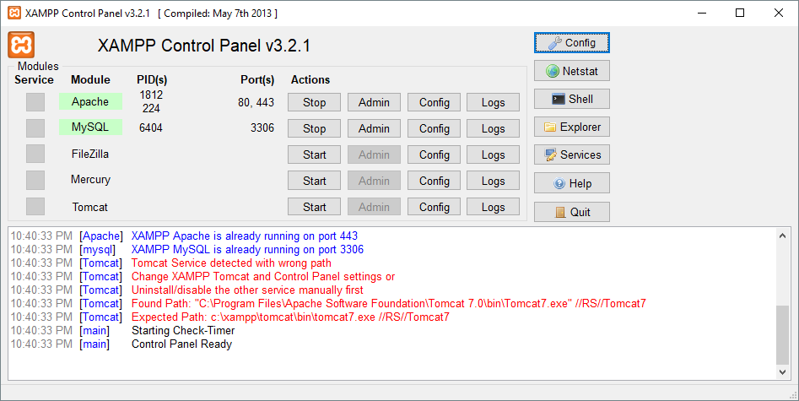

It is a [free and open-source](https://en.wikipedia.org/wiki/Free_and_open-source) [cross-platform](https://en.wikipedia.org/wiki/Cross-platform) [web server](https://en.wikipedia.org/wiki/Web_server) [solution stack](https://en.wikipedia.org/wiki/Solution_stack) package developed by Apache Friends, consisting mainly of the [Apache HTTP Server](https://en.wikipedia.org/wiki/Apache_HTTP_Server), [Maria DB](https://en.wikipedia.org/wiki/MariaDB) [database](https://en.wikipedia.org/wiki/Database), and [interpreters](https://en.wikipedia.org/wiki/Interpreter_(computing)) for scripts written in the [PHP](https://en.wikipedia.org/wiki/PHP) and [Perl](https://en.wikipedia.org/wiki/Perl) [programming languages](https://en.wikipedia.org/wiki/Programming_language). Since most actual web server deployments use the same components as XAMPP, it makes transitioning from a local test server to a live server possible.

XAMPP's ease of deployment means a [WAMP](https://en.wikipedia.org/wiki/WAMP) or [LAMP](https://en.wikipedia.org/wiki/LAMP_(software_bundle)) stack can be installed quickly and simply on an operating system by a developer, with the advantage that common add-in applications such as [Word Press](https://en.wikipedia.org/wiki/WordPress) and [Joomla!](https://en.wikipedia.org/wiki/Joomla!) Can also be installed with similar ease using [Bitnami](https://en.wikipedia.org/wiki/Bitnami).

.**2.3 Database**: **MySQL**

MySQL is an open source relational database management system (RDBMS) based on Structured Query Language (SQL). It is one part of the very popular LAMP platform consisting of Linux, Apache, My SQL, and PHP. Currently My SQL is owned by Oracle. My SQL database is available on most important OS platforms. It runs on BSD Unix, Linux, Windows, or Mac OS. Wikipedia and YouTube use My SQL. These sites manage millions of queries each day. My SQL comes in two versions: My SQL server system and My SQL embedded system.

Before we proceed to explain MySQL database system, let's revise few definitions related to database.

* **Database:**A database is a collection of tables, with related data.
* **Table:**A table is a matrix with data. A table in a database looks like a simple spadsheet.
* **Column:**One column (data element) contains data of one and the same kind, for example the column postcode.
* **Row:**A row (= tuple, entry or record) is a group of related data, for example the data of one subscription.
* **Redundancy:**Storing data twice, redundantly to make the system faster.
* **Primary Key:**A primary key is unique. A key value cannot occur twice in one table. With a key, you can find at most one row.
* **Foreign Key:**A foreign key is the linking pin between two tables.
* **Compound Key:**A compound key (composite key) is a key that consists of multiple columns, because one column is not sufficiently unique.
* **Index:**An index in a database resembles an index at the back of a book.
* **Referential Integrity:**Referential Integrity makes sure that a foreign key value always points to an existing row.

**CHAPTER 03**

**SYSTEM ANALYSIS**

**3.1 EXISTING SYSTEM:**

At the present there is no software to keep any records in blood bank. It becomes difficult to provide any record immediately at times of emergency. Required more human efforts in maintaining the branch related information. Manually to keep the accounts is also tedious & risky job & to maintain those accounts in ledgers for a long period is also very difficult .Difficult to manage and maintain the files. Chance of damage of files, if the data is stored in the files for duration of time. Privacy is difficult. Time consuming is reterving, storing and updating the data. It is difficult to keep track the record about the donor & receiver he has donated or received the blood at the last time.

In the existing system whole process is done manually. Receiver cannot easily get the details about the stock or donors unless they go to blood banks. Blood banks have to prepare the certificate for donors manually.

**3.2 PROPOSED SYSTEM:**

The proposed system (Digital Blood Bank) is designed to help the Blood Bank administrator to meet the demand of Blood by sending and/or serving the request for Blood as and when required. The proposed system gives the procedural approach of how to bridge the gap between Acceptor, Donor, and Blood Banks. This application will provide a common ground for all three parties (i.e. acceptor, donor, and blood banks) and will ensure the fulfilment of demand for blood requested by acceptor and/or Blood Bank. User can easily get the certificate. User can easily get the details about other blood donors.

This Application will provide a common ground for all the parties (i.e. User and Blood Banks) and will ensure the fulfillment of demand for Blood requested by Recipient and/or Blood Bank. The features of proposed system are ease of data entry; system should provide user friendly interfaces, no need to maintain any manual register and form, immediate data retrieval and so on. The new system covers all the aspects of the existing system.

**3.3 SYSTEM MODULE**

**ADMIN:**

Admin should be able to create new users and store their personal and health information in database and also he/she can update the availability of the blood stock.

**USER:**

Here user can easily get the information about the required bloodstock and donor details. They can easily view/download the blood donation certificate at any time if they’ve donated blood.

**3.4 FEASIBILITY STUDY**

A feasibility study is a high-level capsule version of the entire System analysis and Design Process. The study begins by classifying the problem definition. Feasibility is to determine if it’s worth doing. Once an acceptance problem definition has been generated, the analyst develops a logical model of the system. A search for alternatives is analyzed carefully. There are 3 parts in feasibility study.

1) Operational Feasibility

2) Technical Feasibility

3) Economical Feasibility

**3.4.1 Operational Feasibility**

Operational feasibility is the measure of how well a proposed system solves the problems, and takes advantage of the opportunities identified during scope definition and how it satisfies the requirements identified in the requirements analysis phase of system development. The operational feasibility assessment focuses on the degree to which the proposed development projects fits in with the existing business environment and objectives with regard to development schedule, delivery date, corporate culture and existing business processes. To ensure success, desired operational outcomes must be imparted during design and development. These include such design-dependent parameters as reliability, maintainability, supportability, usability, producibility, disposability, sustainability, affordability and others. These parameters are required to be considered at the early stages of design if desired operational behaviors are to be realized. A system design and development requires appropriate and timely application of engineering and management efforts to meet the previously mentioned parameters. A system may serve its intended purpose most effectively when its technical and operating characteristics are engineered into the design. Therefore, operational feasibility is a critical aspect of systems engineering that needs to be an integral part of the early design phases.

**3.4.2 Technical Feasibility**

This involves questions such as whether the technology needed for the system exists, how difficult it will be to build, and whether the firm has enough experience using that technology. The assessment is based on outline design of system requirements in terms of input, processes, output, fields, programs and procedures. This can be qualified in terms of volume of data, trends, frequency of updating in order to give an introduction to the technical system. The application is the fact that it has been developed on windows XP platform and a high configuration of 1GB RAM on Intel Pentium Dual core processor. This is technically feasible .The technical feasibility assessment is focused on gaining an understanding of the present technical resources of the organization and their applicability to the expected needs of the proposed system. It is an evaluation of the hardware and software and how it meets the need of the proposed system.

**3.4.3 Economic Feasibility**

Establishing the cost-effectiveness of the proposed system i.e. if the benefits do not outweigh the costs then it is not worth going ahead. In the fast paced world today there is a great need of online social networking facilities. Thus the benefits of this project in the current scenario make it economically feasible. The purpose of the economic feasibility assessment is to determine the positive economic benefits to the organization that the proposed system will provide. It includes quantification and identification of all the benefits expected. This assessment typically involves a cost/benefits analysis.

**CHAPTER-4**

**SYSTEM REQUIREMENT**

**4.1 HARDWARE REQUIREMENTS**

The most common set of requirements defined by any operating system or software application is the physical computer resources, also known as hardware.

**HARDWARE REQUIREMENTS FOR PRESENT PROJECT:**

Hard Disk: 2 GB.

Ram: 1GB.

**4.2 SOFTWARE REQUIREMENTS**

Software Requirements deal with defining software resource requirements that need to be installed on a computer to provide optimal functioning of an application. These requirements are generally not included in the software installation package and need to be installed separately before the software is installed.

**SOFTWARE REQUIREMENTS FOR PRESENT PROJECT**

Language: PHP

S/W Technologies: CSS3, HTML5.

Web Server: My SQL Server and APACHE Server.

Database: MySQL.

**4.3 FUNCTIONAL REQUIREMENTS**

Use case diagrams are use to describe the functional requirements

1. **ADMIN:-**

* user details
* User health details.
* check availability

1. **USER:-**

* Total donation.
* Check availability.
* Donor’s details.

**4.3.1 Reliability:** The system will consistently perform its intended function Forge. The important information must be validated.

**4.3.2 Efficiency:** Unnecessary data will not be transmitted on the network and database server will be properly connected.

**4.3.3 Reusability:** The system can be reused in any organization or site of the same group, by defining the organization master definition under software license agreement.

**4.3.4 Integrity:** Only System Administrator has rights to access the database, not every user can access all the information. Each user will be having rights to access the modules.

**CHAPTER 05**

**SYSTEM DESIGN**

**DEFINITION**:

The most creative and challenging face of the system development is System Design. It provides the understanding and procedural details necessary for the logical and physical stages of development. In designing a new system, the system analyst must have a clear understanding of the objectives, which the design is aiming to fulfill. The first step is to determine how the output is to be produced and in what format. Second, input data have to be designed to meet the requirements of the proposed output. The operational phases are handled through program construction and testing.

**5.1 System Architecture**

System architecture is the [conceptual model](https://en.wikipedia.org/wiki/Conceptual_model) that defines the [structure](https://en.wikipedia.org/wiki/Structure), [behavior](https://en.wikipedia.org/wiki/Behavior), and more [views](https://en.wikipedia.org/wiki/View_model) of a [system](https://en.wikipedia.org/wiki/System). An architecture description is a formal description and representation of a system, organized in a way that supports reasoning about the [structures](https://en.wikipedia.org/wiki/Structure) and [behaviors](https://en.wikipedia.org/wiki/Behavior) of the system. A system architecture can consist of system [components](https://en.wikipedia.org/wiki/System) and the sub-systems developed, that will work together to implement the overall system.

**5.2 DATAFLOW DIAGRAM**

The DFD takes an input-process-output view of a system i.e. data objects flow into the software, are transformed by processing elements, and resultant data objects flow out of the software. Data objects represented by labeled arrows and transformation are represented by circles also called as bubbles.

**Level 0 DFD**

A context diagram is a top level (also known as level 0) data flow diagram. It only contains one process node that generalizes the function of the entire system in relationship to external entities. In level 0 DFD, system is shown as one process.

The level 0 DFD shows how the system is divided into sub-system(processes),each of which deals with one or more of the data flows to or from an external agent ,and which together provide all the functionality of the system as a whole. It also identifies internal data stores that must be present in order for the system to do its job and shows the flow of data between the various parts of the system.

**Data Flow Diagram:**

Login to the Blood Bank Management System

Start

Check User Level and Permission

Check Permission

Logout from the System

Admin User (ACCEPTER/DONOR)

Manage User, Donor Health Details and stock

Download certificate, check for blood availability.

Logout from the System

Stop

**5.3 E-R DIAGRAM**

An Entity Relationship Diagram (ERD) is a visual representation of different entities within a system and how they relate to each other. For example, the elements writer, novel, and a consumer may be described using ER diagrams the following way:

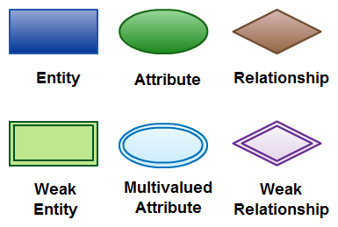`

**Entity:**

* An entity can be a person, place, event, or object that is relevant to a given system.
* For example, a school system may include students, teachers, major courses, subjects, fees, and other items. Entities are represented in ER diagrams by a rectangle and named using singular nouns.

**Attribute:**

* An attribute is a property, trait, or characteristic of an entity, relationship, or another attribute.
* For example, the attribute “customer address” can have the attributes number, street, city, and state. These are called composite attributes

**Relationship:**

A relationship describes how entities interact. For example, the entity “Carpenter” may be related to the entity “table” by the relationship “builds” or “makes”. Relationships are represented by diamond shapes and are labeled using verbs.

**5.4 E-R DIAGRAM USER:**

**5.5 E –R DIAGRAM FOR ADMIN:**

**5.6 DATABASE CONNECTIVITY:**

PHP Database objects will work on 12 different database systems, whereas MySQL will only work with MySQL databases.

So, if you have to switch your project to use another database, PHP Database objects makes the process easy. You only have to change the connection string and a few queries. With MySQL, you will need to rewrite the entire code - queries included.

Both are object-oriented, but MySQL also offers a procedural API.

Both support Prepared Statements. Prepared Statements protect from SQL injection, and are very important for web application security.

<?php  
mysql_connect("localhost", " user_name ", "password");

mysql_select_db("data_base");  
?>

**5.7 SESSION:**

When you work with an application, you open it, do some changes, and then you close it. This is much like a Session. The computer knows who you are. It knows when you start the application and when you end. But on the internet there is one problem: the web server does not know who you are or what you do, because the HTTP address doesn't maintain state.

Session variables solve this problem by storing user information to be used across multiple pages (e.g. username, favorite color, etc.). By default, session variables last until the user closes the browser.

So; Session variables hold information about one single user, and are available to all pages in one application.

## Start a PHP Session

A session is started with the session_start() function.

Session variables are set with the PHP global variable: $_SESSION.

<?php  
// Start the session  
session_start();  
?>  
<!DOCTYPE html>  
<html>  
<body>  
  
<?php  
// Set session variables  
$_SESSION["favcolor"] = "green";  
$_SESSION["favanimal"] = "cat";  
echo "Session variables are set.";  
?>

**5.8 MD5 ENCRYPTION:**

The md5() function calculates the MD5 hash of a string.

The md5() function uses the RSA Data Security, Inc. MD5 Message-Digest Algorithm.

From RFC 1321 - The MD5 Message-Digest Algorithm: “ The MD5 message-digest algorithm takes as input a message of arbitrary length and produces as output a 128-bit "fingerprint" or "message digest" of the input. The MD5 algorithm is intended for digital signature applications, where a large file must be "compressed" in a secure manner before being encrypted with a private (secret) key under a public-key cryptosystem such as RSA."

## Syntax

md5(string,raw)

## Parameter Values

**Parameter Description   
String** Required. The string to be calculated

**Raw** Optional. Specifies hex or binary output format:

* TRUE - Raw 16 character binary format.
* FALSE - Default. 32 character hex number.

**TESTING**

**PURPOSE OF TESTING**

The purpose of testing is to discover errors. Testing is the process of trying to discover every conceivable fault or weakness in a work product. It provides a way to check the functionality of components. Testing is a crucial element of software quality assurance and presents ultimate review of specification, design and coding. System Testing is an important phase. Testing represents an interesting anomaly for the software.  Thus a series of testing are performed for the proposed system before the system is ready for user acceptance testing.

In other words software testing is a verification and validation process.

#### **Verification**

Verification is the process to make sure the product satisfies the conditions imposed at the start of the development phase. In other words, to make sure the product behaves the way we want it to.

#### **Validation**

Validation is the process to make sure the product satisfies the specified requirements at the end of the development phase. In other words, to make sure the product is built as per customer requirements.

**TYPES OF TESTING:**

##### **Black box Testing**

Black-box testing is a method of software testing that examines the functionality of an application without peering into its internal structures or workings. This method of test can be applied virtually to every level of software testing: unit, integration, system and acceptance. It typically comprises most if not all higher level testing, but can also dominate unit testing as well.

##### **White box Testing**

White-box testing (also known as clear box testing, glass box testing, transparent box testing, and structural testing) is a method of testing software that tests internal structures or workings of an application, as opposed to its functionality (i.e. black-box testing). In white-box testing an internal perspective of the system, as well as programming skills, are used to design test cases. The tester chooses inputs to exercise paths through the code and determine the appropriate outputs. This is analogous to testing nodes in a circuit, e.g. in-circuit testing (ICT). White-box testing can be applied at the unit, integration and system levels of the software testing process. Although traditional testers tended to think of white-box testing as being done at the unit level, it is used for integration and system testing more frequently today. It can test paths within a unit, paths between units during integration, and between subsystems during a system–level test. Though this method of test design can uncover many errors or problems, it has the potential to miss unimplemented parts of the specification or missing requirements.

**LEVELS OF TESTING:**

* Unit Testing
* Integration Testing
* Functional Testing
* System Testing
* Stress Testing
* Performance Testing
* Usability Testing
* Acceptance Testing
* Regression Testing
* Beta Testing

##### **Unit Testing**

White-box testing is done during unit testing to ensure that the code is working as intended, before any integration happens with previously tested code. White-box testing during unit testing catches any defects early on and aids in any defects that happen later on after the code is integrated with the rest of the application and therefore prevents any type of errors later on.

##### **Integration Testing**

White-box testing at this level are written to test the interactions of each interface with each other. The Unit level testing made sure that each code was tested and working accordingly in an isolated environment and integration examines the correctness of the behavior in an open environment through the use of white-box testing for any interactions of interfaces that are known to the programmer.

##### **Functional Testing**

Functional Testing is defined as a type of testing which verifies that each function of the software application operates in conformance with the requirement specification. This testing mainly involves black box testing and it is not concerned about the source code of the application.

Each and every functionality of the system is tested by providing appropriate input, verifying the output and comparing the actual results with the expected results.

**System Testing**

System Testing is the testing of a complete and fully integrated software product. System testing is the testing to ensure that by putting the software in different environments (e.g., Operating Systems) it still works. System testing is done with full system implementation and environment. It falls under the class of black box testing.

**Stress Testing**

Stress Testing is defined as a type of Software Testing that verified the stability & reliability of the system. This test mainly determines the system on its robustness and error handling under extremely heavy load conditions.

It even tests beyond the normal operating point and evaluates how the system works under those extreme conditions. Stress Testing is done to make sure that the system would not crash under crunch situations.

**Performance Testing**

Performance Testing is defined as a type of software testing to ensure software applications will perform well under their expected workload. . A software application's performance like its response time, reliability, resource usage and scalability do matter. The goal of Performance Testing is not to find bugs but to eliminate it.

The focus of Performance Testing is checking a software program's

* Speed - Determines whether the application responds quickly
* Scalability - Determines maximum user load the software application can handle.
* Stability - Determines if the application is stable under varying loads

**Usability Testing**

Usability Testing is defined as a type of software testing where, a small set of target end-users, of a software system, "use" it to expose usability defects. This testing mainly focuses on the user's ease to use the application, flexibility in handling controls and the ability of the system to meet its objectives.

**Acceptance Testing:**

User Acceptance Testing is a critical phase of any project and requires significant participation by the end user. It also ensures that the system meets the functional requirements

**Regression Testing**

Regression Testing is defined as a type of software testing to confirm that a recent program or code change has not adversely affected existing features.

Regression Testing is nothing but a full or partial selection of already executed test cases which are re-executed to ensure existing functionalities work fine.

**Beta Testing**

Beta Testing of a product is performed by "real users" of the software application in a real environment and can be considered as a form of external [User Acceptance Testing](https://www.guru99.com/user-acceptance-testing.html).

Beta version of the software is released to a limited number of end-users of the product to obtain feedback on the product quality. Beta testing reduces product failure risks and provides increased quality of the product through customer validation.

**SNAPSHOTS**

**Home page:** This is the default landing page of Digital Blood Bank.

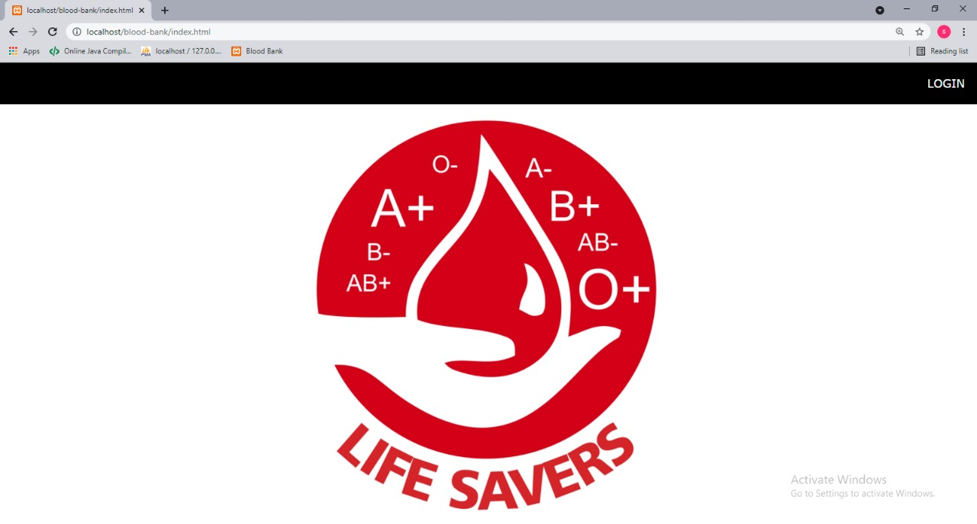

**Login page:** In this login page it will check the user level permission and display the respective pages according the assigned role.

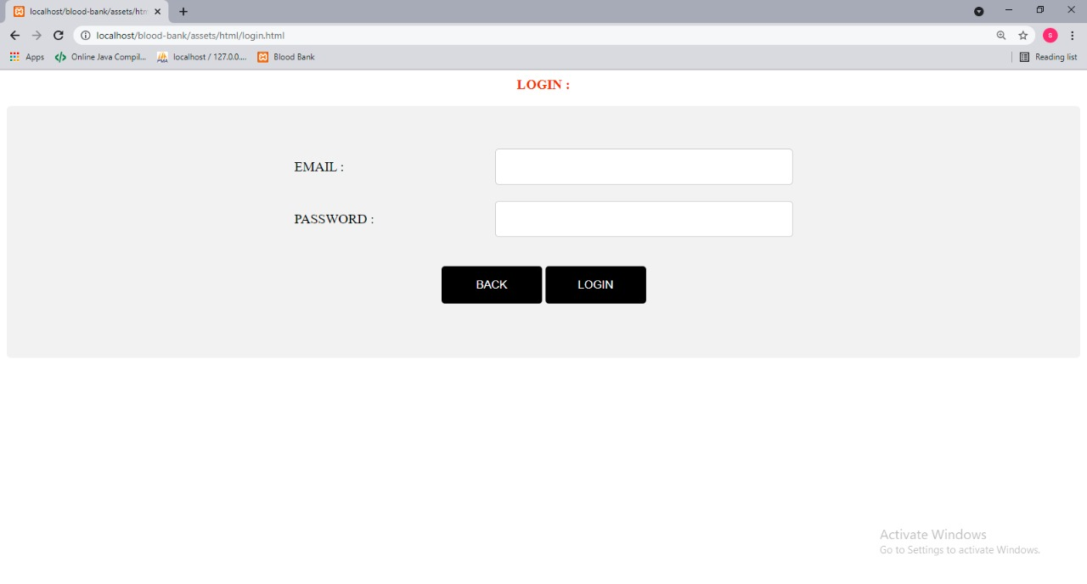

**Admin page:** Coming to the admin page it allows administrator to update user details and stock details.

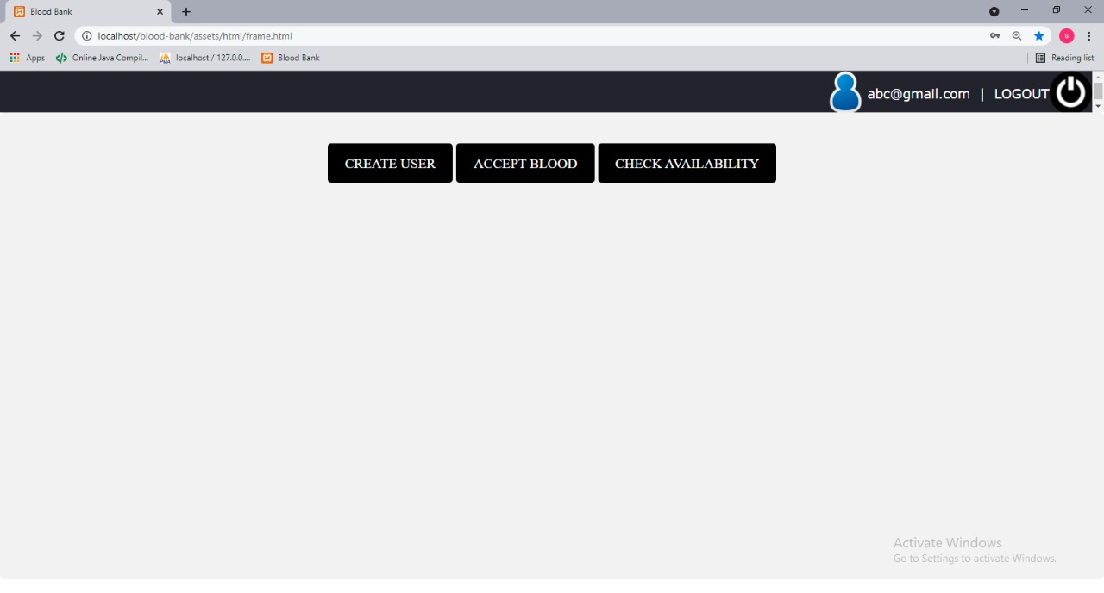

**User details:** In this page administrator creates new user and their personal informations like as shown in the below figure.

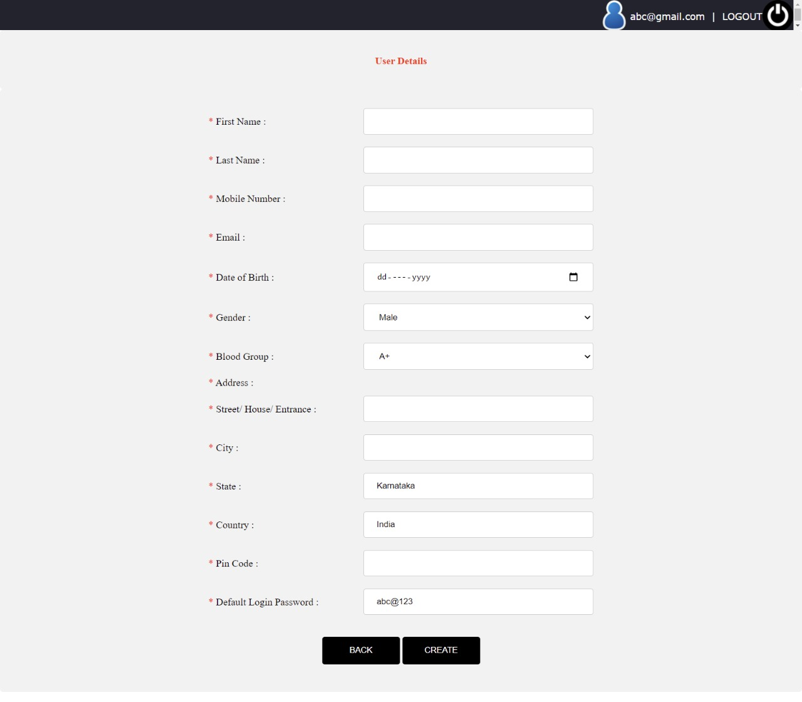

**User health details:** In thispageadmin updates the user’s health details when came to donate blood.

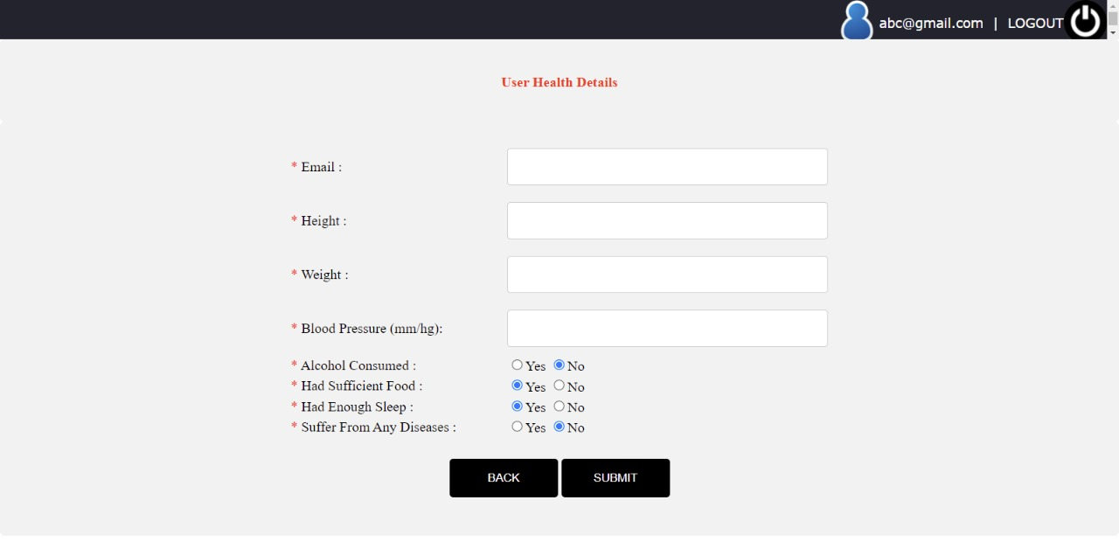

**Check availability:** In this page admin get the stock details and donors information according to their respective blood group.

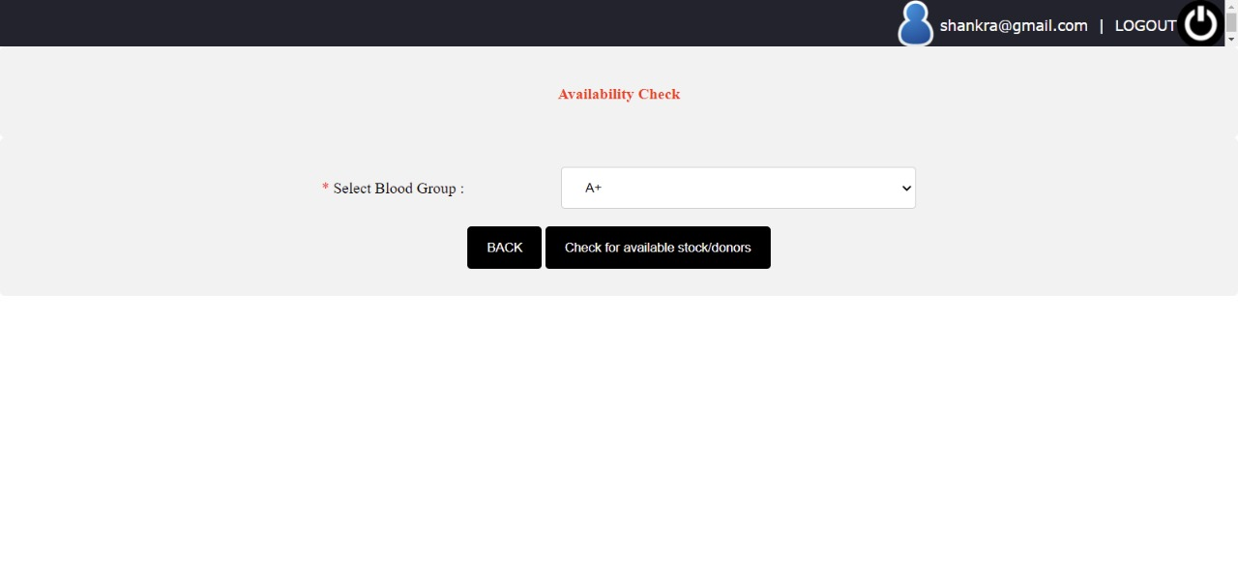

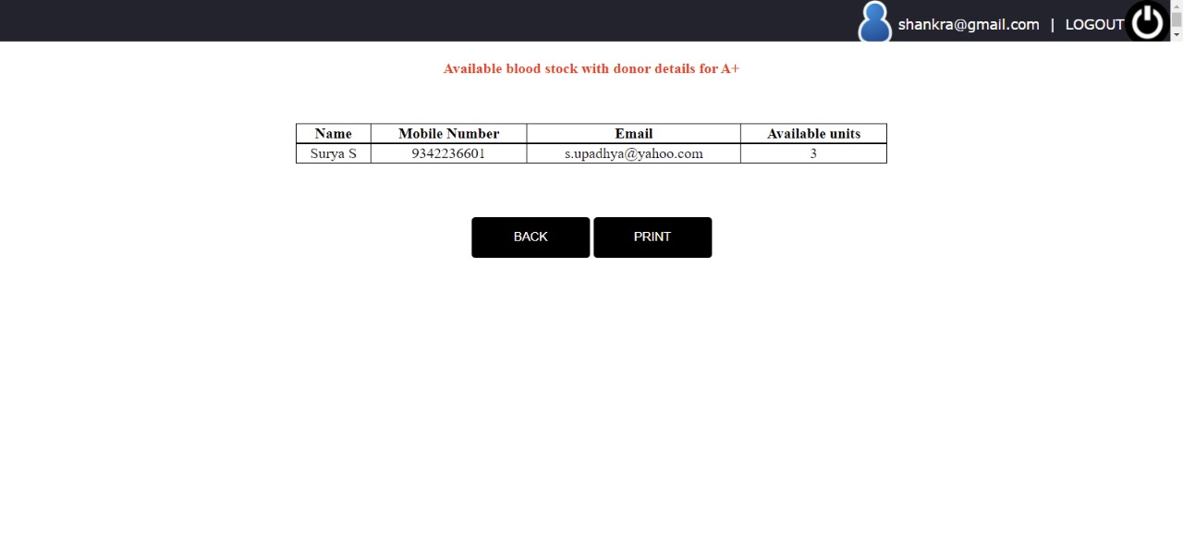

**User Page:** According to role user get this page after they login here they can see to option check availability and total donations**.**

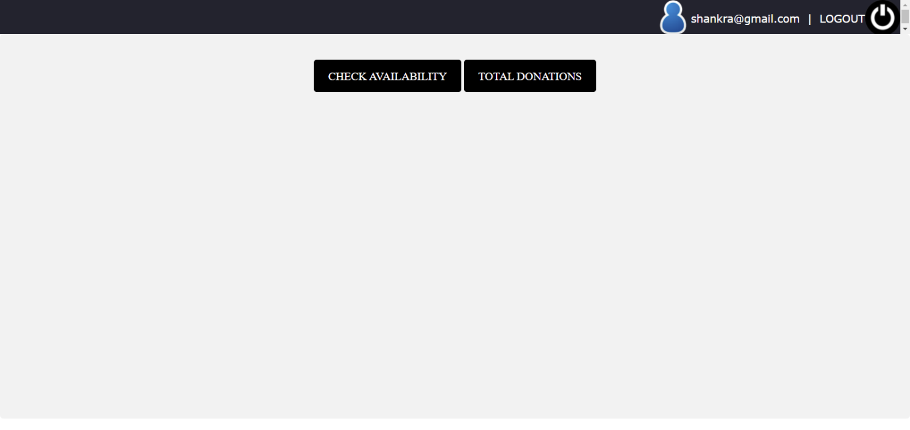

**Total donations:** In the total donation page he/she get their health details and last time donated and they will get option to view their certificate.

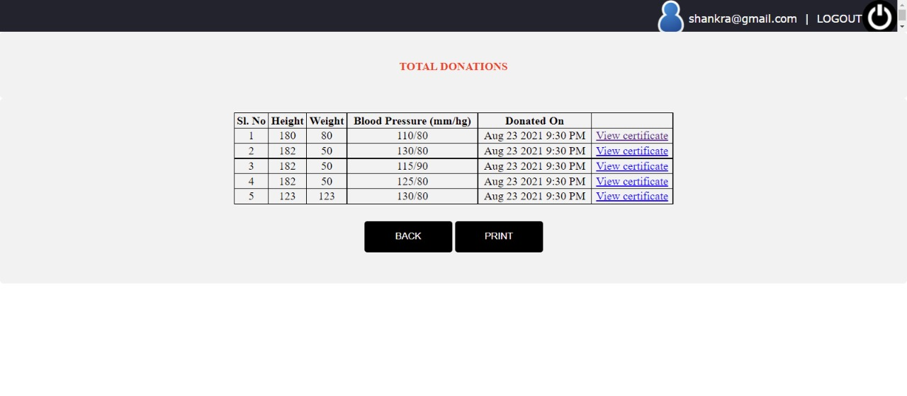**Certificate:** In certificate they it displays user name,blood group,donated date, number of time they donated.

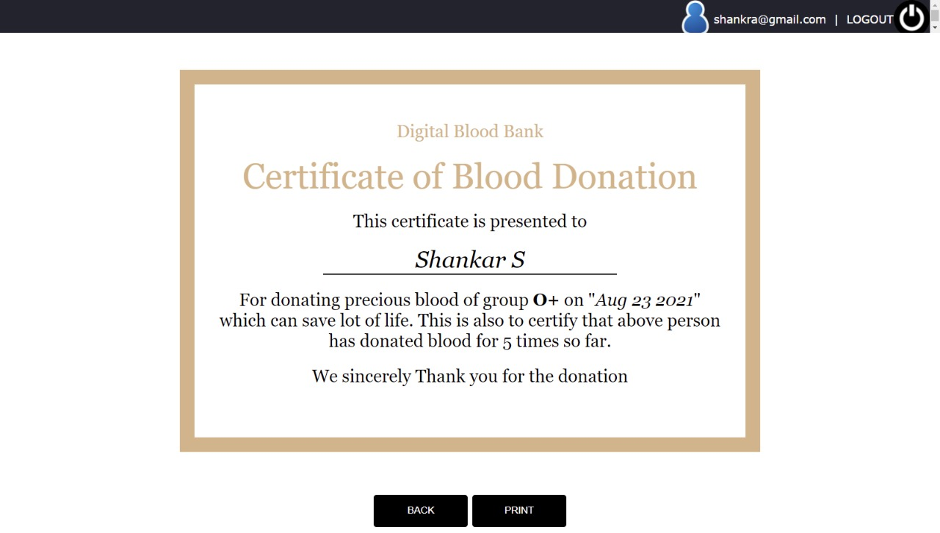

**Check availability:** In this page user get the stock details and donors information according to their respective blood group.





**CONCLUSION**

**Conclusion:**

* It tracks all the details of the donor, blood bank.
* Blood stocks all fields such as blood, blood group, blood stock are validated does not take invalid values.
* We can easily get the certificate of blood donation. In the form of soft copy like PDF or etc.
* We can keep track of number of donations.
* Blood availability can be checked within few clicks.

**FUTURE ENHANCMENT**

* Complete digitalization of blood bank operation.
* Can be extended to check availability of plasma, kidney, lever, eyes, heart and other critical medical essentials which can save lot of life and help in quick availability of this in no time.
* Blood Bank Management System is a web program to build in such a way that it should suites all type of blood bank in the future.
* One important future scope is availability of the location based on blood bank details and extraction of location based on donor’s detail, which is very helpful to the acceptant people. All the time the network facilities cannot be used. This time donor request does not reach in proper time, this can be avoid through adding some message sending procedure this will help to find proper blood donor in the time. This will provide availability of blood in time.